

Assignment

DIGITAL IMAGE AND VIDEO PROCESSING

Arnav Malhotra | 17317424 | 17/04/2019

**A1a.** Following is the code snippet which was added in order to calculate the MAE for each vector:

for kx = -w:w,

for ky = -w:w,

past_block = past_frame(by + ky,bx + kx);

error(1+w+ky,1+w+kx) = mean(mean(abs(reference_block - past_block)));

end

end

**A1b.** Below is the code added for displaying DFD matrix:

%display your dfd as figure 4!

figure(4);image(dfd);

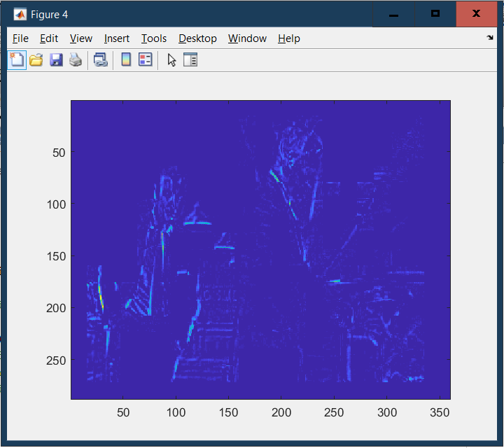

**A1.1.** Given below is the code snippet fir plotting the graph:

%INSERT YOUR SINGLE LINE OF DISPLAY CODE HERE!!

figure(5);plot(dfdOfFrames);xlabel('Frame');

ylabel('En,n-1');

title('Plot En,n-1 Vs Frame');

And following is the required graph:

